Стоянова-Серафимова, Д. Римска военна диплома от с. Лешко, Благоевградско.
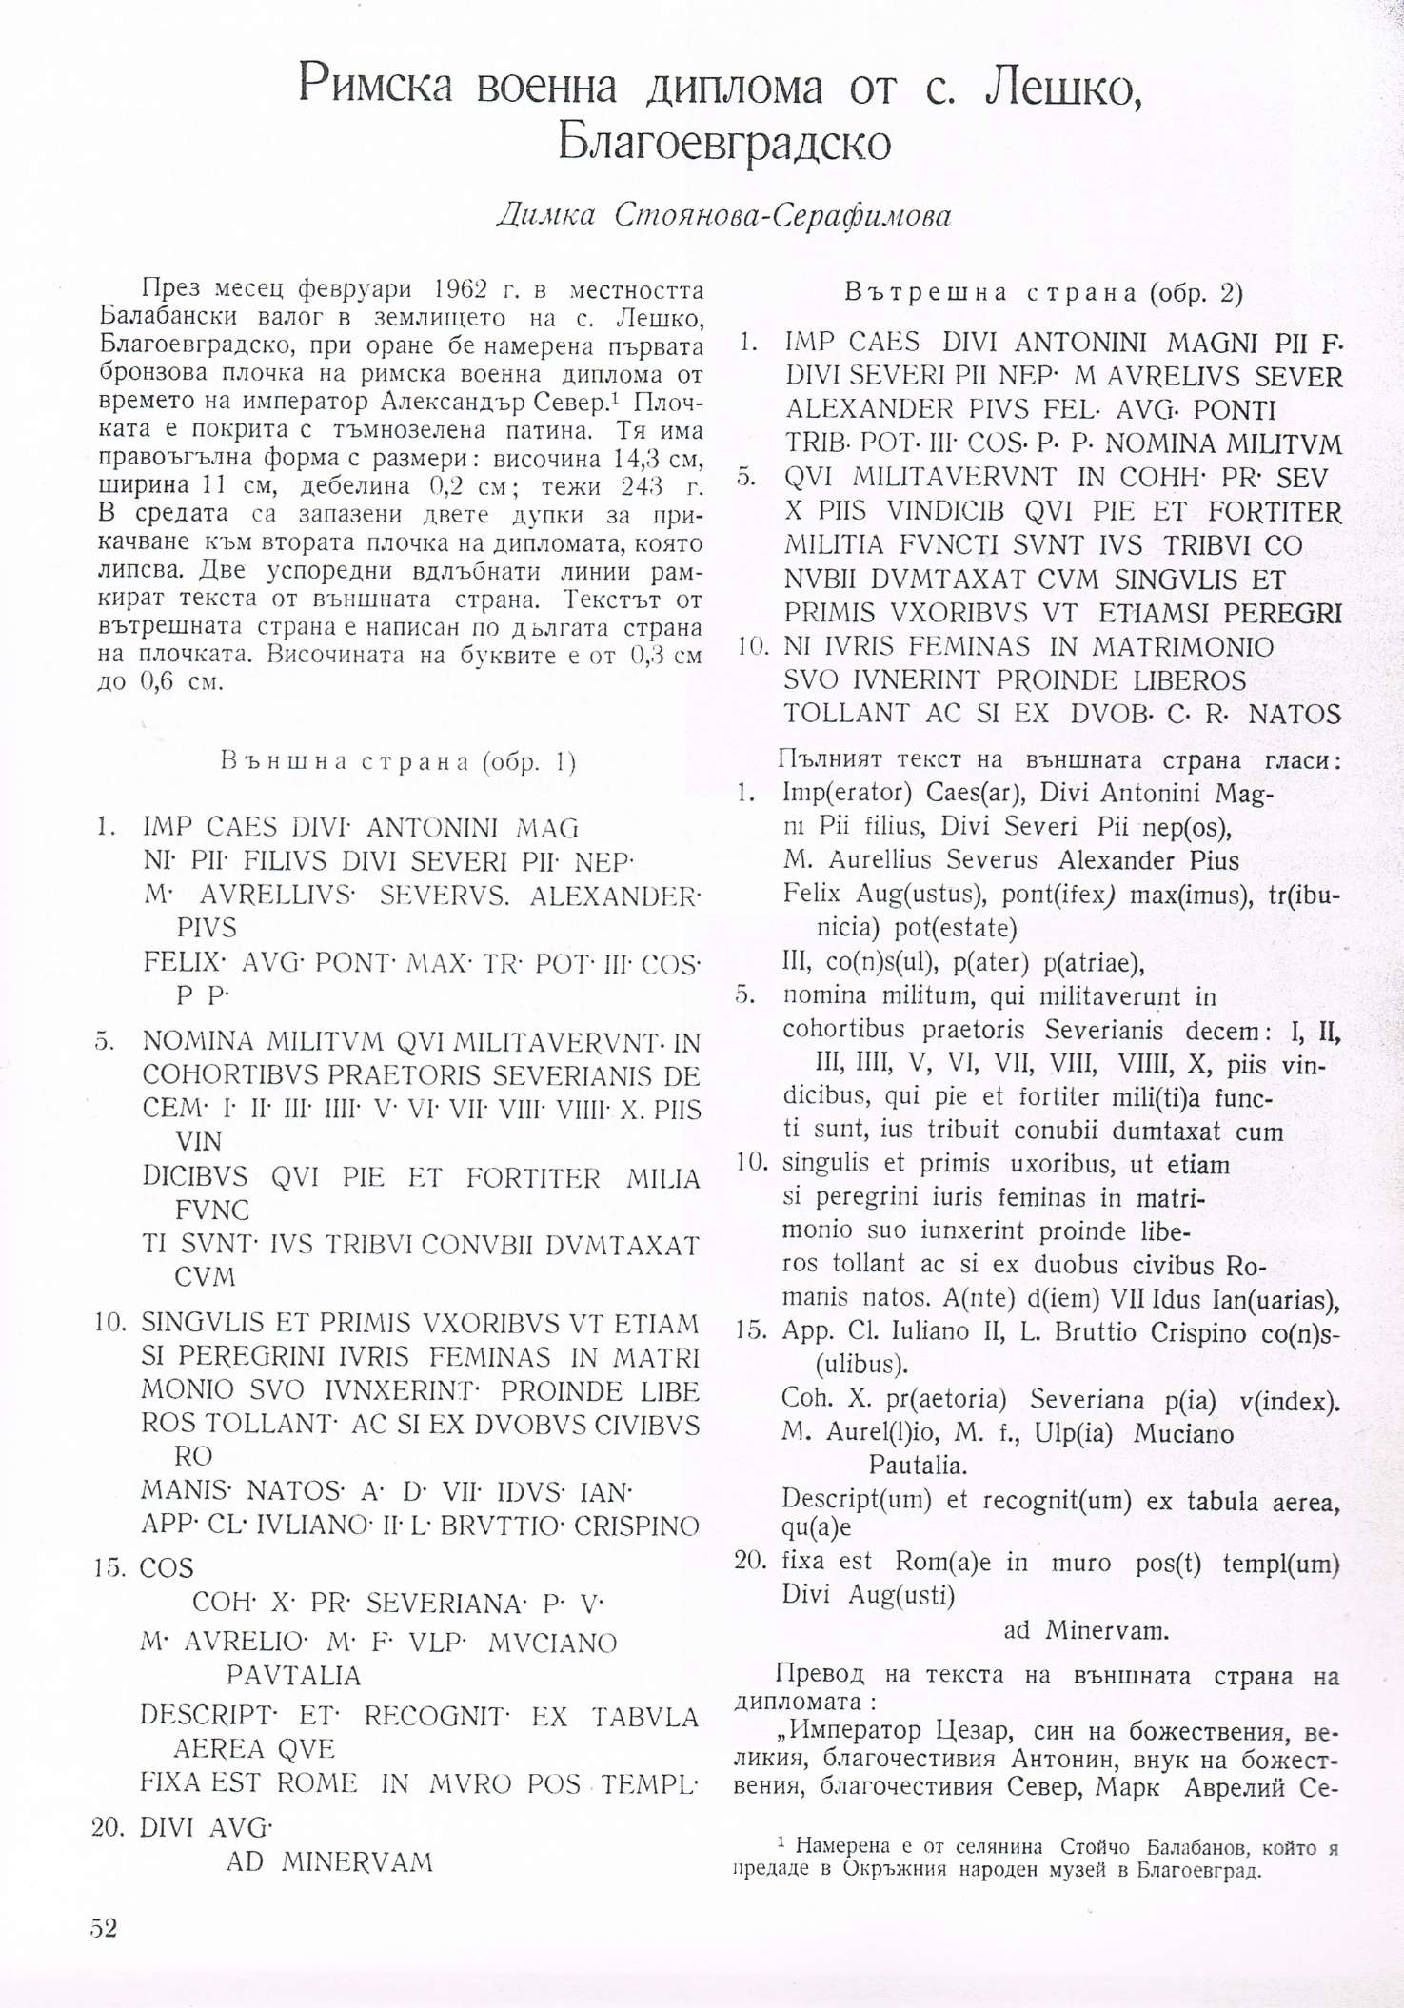

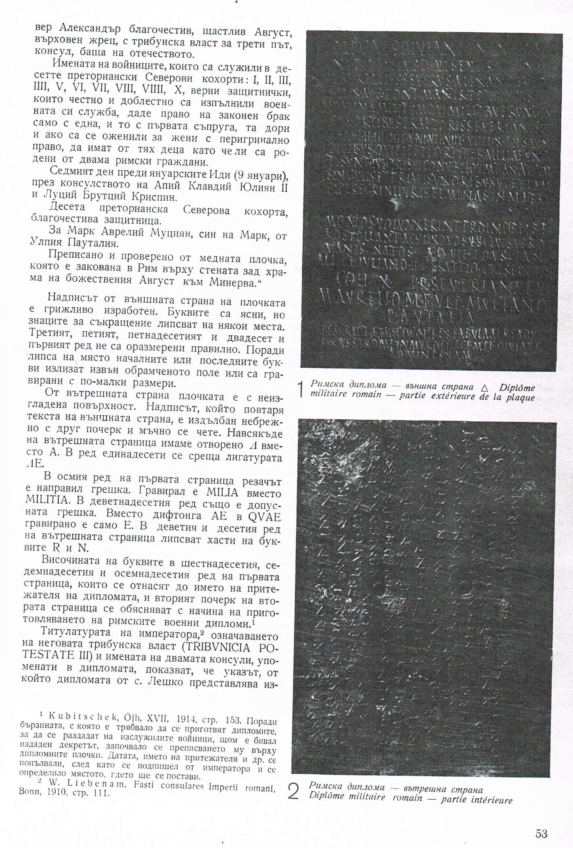

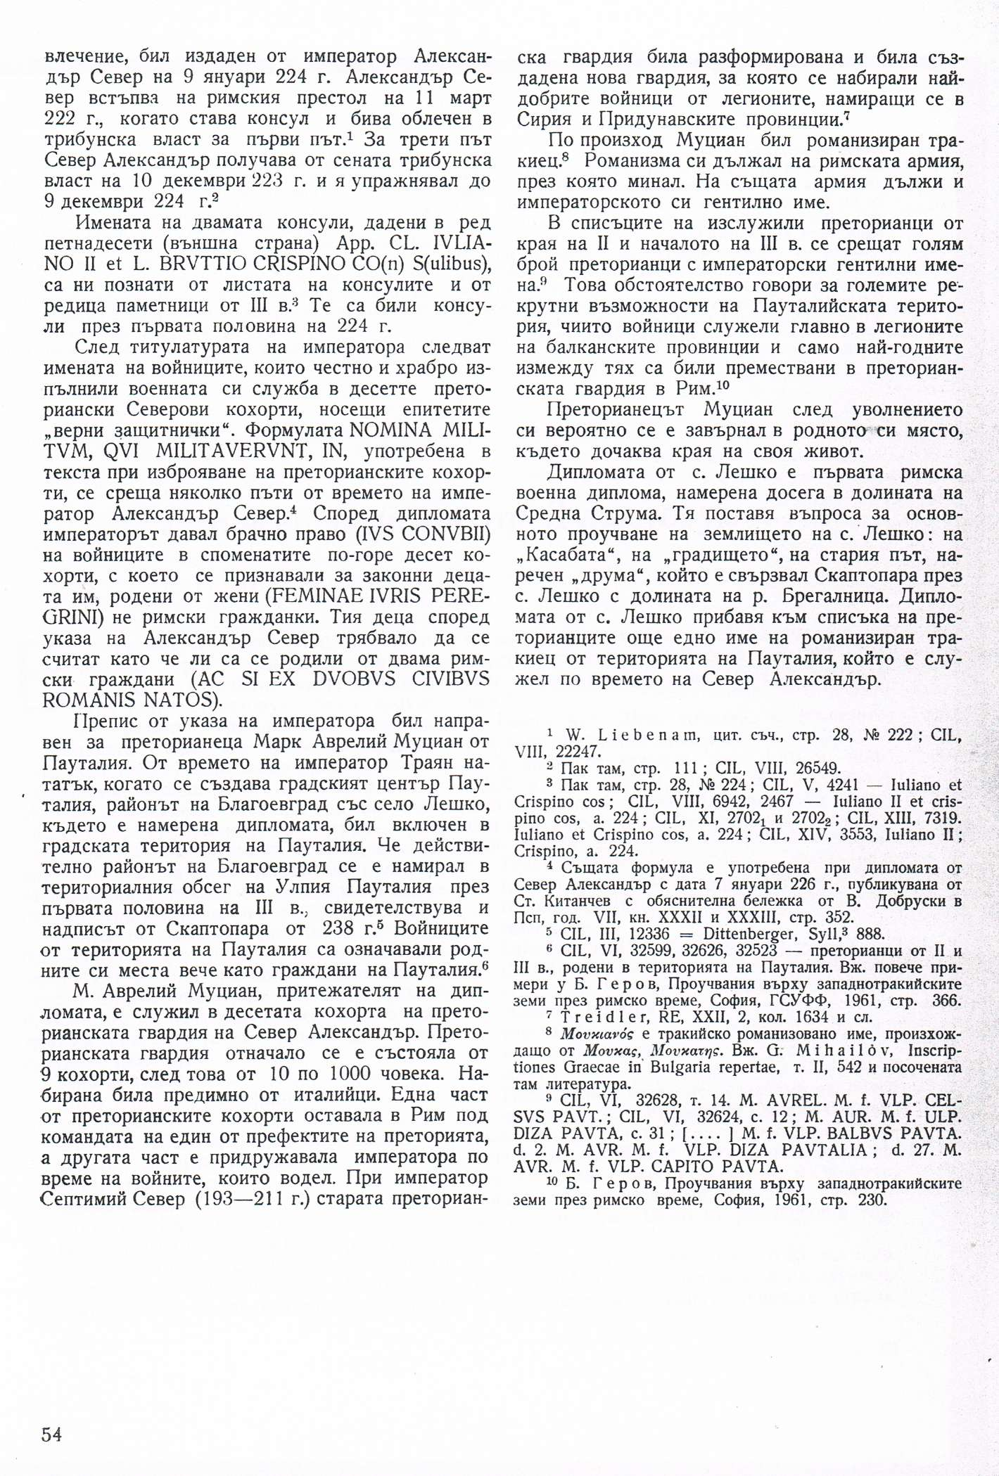

Стоянова-Серафимова, Д. Римска военна диплома от с. Лешко, Благоевградско. А., 1962, 4, с. 52-54.

INCLUDEPICTURE "http://t0.gstatic.com/images?q=tbn:ANd9GcTDT1jpfS6n_Y4NmsXFnf0dV2uAk854tEHeOSaIXPxUCt7qxHu5xaSaZA" \* MERGEFORMATINET INCLUDEPICTURE "http://t0.gstatic.com/images?q=tbn:ANd9GcTDT1jpfS6n_Y4NmsXFnf0dV2uAk854tEHeOSaIXPxUCt7qxHu5xaSaZA" \* MERGEFORMATINET INCLUDEPICTURE "http://t0.gstatic.com/images?q=tbn:ANd9GcTDT1jpfS6n_Y4NmsXFnf0dV2uAk854tEHeOSaIXPxUCt7qxHu5xaSaZA" \* MERGEFORMATINET INCLUDEPICTURE "http://t0.gstatic.com/images?q=tbn:ANd9GcTDT1jpfS6n_Y4NmsXFnf0dV2uAk854tEHeOSaIXPxUCt7qxHu5xaSaZA" \* MERGEFORMATINET INCLUDEPICTURE "http://t0.gstatic.com/images?q=tbn:ANd9GcTDT1jpfS6n_Y4NmsXFnf0dV2uAk854tEHeOSaIXPxUCt7qxHu5xaSaZA" \* MERGEFORMATINET INCLUDEPICTURE "http://t0.gstatic.com/images?q=tbn:ANd9GcTDT1jpfS6n_Y4NmsXFnf0dV2uAk854tEHeOSaIXPxUCt7qxHu5xaSaZA" \* MERGEFORMATINET INCLUDEPICTURE "http://t0.gstatic.com/images?q=tbn:ANd9GcTDT1jpfS6n_Y4NmsXFnf0dV2uAk854tEHeOSaIXPxUCt7qxHu5xaSaZA" \* MERGEFORMATINET INCLUDEPICTURE "http://t0.gstatic.com/images?q=tbn:ANd9GcTDT1jpfS6n_Y4NmsXFnf0dV2uAk854tEHeOSaIXPxUCt7qxHu5xaSaZA" \* MERGEFORMATINET INCLUDEPICTURE "http://t0.gstatic.com/images?q=tbn:ANd9GcTDT1jpfS6n_Y4NmsXFnf0dV2uAk854tEHeOSaIXPxUCt7qxHu5xaSaZA" \* MERGEFORMATINET INCLUDEPICTURE "http://t0.gstatic.com/images?q=tbn:ANd9GcTDT1jpfS6n_Y4NmsXFnf0dV2uAk854tEHeOSaIXPxUCt7qxHu5xaSaZA" \* MERGEFORMATINET INCLUDEPICTURE "http://t0.gstatic.com/images?q=tbn:ANd9GcTDT1jpfS6n_Y4NmsXFnf0dV2uAk854tEHeOSaIXPxUCt7qxHu5xaSaZA" \* MERGEFORMATINET INCLUDEPICTURE "http://t0.gstatic.com/images?q=tbn:ANd9GcTDT1jpfS6n_Y4NmsXFnf0dV2uAk854tEHeOSaIXPxUCt7qxHu5xaSaZA" \* MERGEFORMATINET INCLUDEPICTURE "http://t0.gstatic.com/images?q=tbn:ANd9GcTDT1jpfS6n_Y4NmsXFnf0dV2uAk854tEHeOSaIXPxUCt7qxHu5xaSaZA" \* MERGEFORMATINET INCLUDEPICTURE "http://t0.gstatic.com/images?q=tbn:ANd9GcTDT1jpfS6n_Y4NmsXFnf0dV2uAk854tEHeOSaIXPxUCt7qxHu5xaSaZA" \* MERGEFORMATINET INCLUDEPICTURE "http://t0.gstatic.com/images?q=tbn:ANd9GcTDT1jpfS6n_Y4NmsXFnf0dV2uAk854tEHeOSaIXPxUCt7qxHu5xaSaZA" \* MERGEFORMATINET INCLUDEPICTURE "http://t0.gstatic.com/images?q=tbn:ANd9GcTDT1jpfS6n_Y4NmsXFnf0dV2uAk854tEHeOSaIXPxUCt7qxHu5xaSaZA" \* MERGEFORMATINET INCLUDEPICTURE "http://t0.gstatic.com/images?q=tbn:ANd9GcTDT1jpfS6n_Y4NmsXFnf0dV2uAk854tEHeOSaIXPxUCt7qxHu5xaSaZA" \* MERGEFORMATINET INCLUDEPICTURE "http://t0.gstatic.com/images?q=tbn:ANd9GcTDT1jpfS6n_Y4NmsXFnf0dV2uAk854tEHeOSaIXPxUCt7qxHu5xaSaZA" \* MERGEFORMATINET INCLUDEPICTURE "http://t0.gstatic.com/images?q=tbn:ANd9GcTDT1jpfS6n_Y4NmsXFnf0dV2uAk854tEHeOSaIXPxUCt7qxHu5xaSaZA" \* MERGEFORMATINET INCLUDEPICTURE "http://t0.gstatic.com/images?q=tbn:ANd9GcTDT1jpfS6n_Y4NmsXFnf0dV2uAk854tEHeOSaIXPxUCt7qxHu5xaSaZA" \* MERGEFORMATINET INCLUDEPICTURE "http://t0.gstatic.com/images?q=tbn:ANd9GcTDT1jpfS6n_Y4NmsXFnf0dV2uAk854tEHeOSaIXPxUCt7qxHu5xaSaZA" \* MERGEFORMATINET INCLUDEPICTURE "http://t0.gstatic.com/images?q=tbn:ANd9GcTDT1jpfS6n_Y4NmsXFnf0dV2uAk854tEHeOSaIXPxUCt7qxHu5xaSaZA" \* MERGEFORMATINET INCLUDEPICTURE "http://t0.gstatic.com/images?q=tbn:ANd9GcTDT1jpfS6n_Y4NmsXFnf0dV2uAk854tEHeOSaIXPxUCt7qxHu5xaSaZA" \* MERGEFORMATINET INCLUDEPICTURE "http://t0.gstatic.com/images?q=tbn:ANd9GcTDT1jpfS6n_Y4NmsXFnf0dV2uAk854tEHeOSaIXPxUCt7qxHu5xaSaZA" \* MERGEFORMATINET INCLUDEPICTURE "http://t0.gstatic.com/images?q=tbn:ANd9GcTDT1jpfS6n_Y4NmsXFnf0dV2uAk854tEHeOSaIXPxUCt7qxHu5xaSaZA" \* MERGEFORMATINET INCLUDEPICTURE "http://t0.gstatic.com/images?q=tbn:ANd9GcTDT1jpfS6n_Y4NmsXFnf0dV2uAk854tEHeOSaIXPxUCt7qxHu5xaSaZA" \* MERGEFORMATINET INCLUDEPICTURE "http://t0.gstatic.com/images?q=tbn:ANd9GcTDT1jpfS6n_Y4NmsXFnf0dV2uAk854tEHeOSaIXPxUCt7qxHu5xaSaZA" \* MERGEFORMATINET INCLUDEPICTURE "http://t0.gstatic.com/images?q=tbn:ANd9GcTDT1jpfS6n_Y4NmsXFnf0dV2uAk854tEHeOSaIXPxUCt7qxHu5xaSaZA" \* MERGEFORMATINET INCLUDEPICTURE "http://t0.gstatic.com/images?q=tbn:ANd9GcTDT1jpfS6n_Y4NmsXFnf0dV2uAk854tEHeOSaIXPxUCt7qxHu5xaSaZA" \* MERGEFORMATINET INCLUDEPICTURE "http://t0.gstatic.com/images?q=tbn:ANd9GcTDT1jpfS6n_Y4NmsXFnf0dV2uAk854tEHeOSaIXPxUCt7qxHu5xaSaZA" \* MERGEFORMATINET INCLUDEPICTURE "http://t0.gstatic.com/images?q=tbn:ANd9GcTDT1jpfS6n_Y4NmsXFnf0dV2uAk854tEHeOSaIXPxUCt7qxHu5xaSaZA" \* MERGEFORMATINET INCLUDEPICTURE "http://t0.gstatic.com/images?q=tbn:ANd9GcTDT1jpfS6n_Y4NmsXFnf0dV2uAk854tEHeOSaIXPxUCt7qxHu5xaSaZA" \* MERGEFORMATINET INCLUDEPICTURE "http://t0.gstatic.com/images?q=tbn:ANd9GcTDT1jpfS6n_Y4NmsXFnf0dV2uAk854tEHeOSaIXPxUCt7qxHu5xaSaZA" \* MERGEFORMATINET INCLUDEPICTURE "http://t0.gstatic.com/images?q=tbn:ANd9GcTDT1jpfS6n_Y4NmsXFnf0dV2uAk854tEHeOSaIXPxUCt7qxHu5xaSaZA" \* MERGEFORMATINET INCLUDEPICTURE "http://t0.gstatic.com/images?q=tbn:ANd9GcTDT1jpfS6n_Y4NmsXFnf0dV2uAk854tEHeOSaIXPxUCt7qxHu5xaSaZA" \* MERGEFORMATINET INCLUDEPICTURE "http://t0.gstatic.com/images?q=tbn:ANd9GcTDT1jpfS6n_Y4NmsXFnf0dV2uAk854tEHeOSaIXPxUCt7qxHu5xaSaZA" \* MERGEFORMATINET INCLUDEPICTURE "http://t0.gstatic.com/images?q=tbn:ANd9GcTDT1jpfS6n_Y4NmsXFnf0dV2uAk854tEHeOSaIXPxUCt7qxHu5xaSaZA" \* MERGEFORMATINET INCLUDEPICTURE "http://t0.gstatic.com/images?q=tbn:ANd9GcTDT1jpfS6n_Y4NmsXFnf0dV2uAk854tEHeOSaIXPxUCt7qxHu5xaSaZA" \* MERGEFORMATINET INCLUDEPICTURE "http://t0.gstatic.com/images?q=tbn:ANd9GcTDT1jpfS6n_Y4NmsXFnf0dV2uAk854tEHeOSaIXPxUCt7qxHu5xaSaZA" \* MERGEFORMATINET INCLUDEPICTURE "http://t0.gstatic.com/images?q=tbn:ANd9GcTDT1jpfS6n_Y4NmsXFnf0dV2uAk854tEHeOSaIXPxUCt7qxHu5xaSaZA" \* MERGEFORMATINET INCLUDEPICTURE "http://t0.gstatic.com/images?q=tbn:ANd9GcTDT1jpfS6n_Y4NmsXFnf0dV2uAk854tEHeOSaIXPxUCt7qxHu5xaSaZA" \* MERGEFORMATINET INCLUDEPICTURE "http://t0.gstatic.com/images?q=tbn:ANd9GcTDT1jpfS6n_Y4NmsXFnf0dV2uAk854tEHeOSaIXPxUCt7qxHu5xaSaZA" \* MERGEFORMATINET INCLUDEPICTURE "http://t0.gstatic.com/images?q=tbn:ANd9GcTDT1jpfS6n_Y4NmsXFnf0dV2uAk854tEHeOSaIXPxUCt7qxHu5xaSaZA" \* MERGEFORMATINET INCLUDEPICTURE "http://t0.gstatic.com/images?q=tbn:ANd9GcTDT1jpfS6n_Y4NmsXFnf0dV2uAk854tEHeOSaIXPxUCt7qxHu5xaSaZA" \* MERGEFORMATINET INCLUDEPICTURE "http://t0.gstatic.com/images?q=tbn:ANd9GcTDT1jpfS6n_Y4NmsXFnf0dV2uAk854tEHeOSaIXPxUCt7qxHu5xaSaZA" \* MERGEFORMATINET INCLUDEPICTURE "http://t0.gstatic.com/images?q=tbn:ANd9GcTDT1jpfS6n_Y4NmsXFnf0dV2uAk854tEHeOSaIXPxUCt7qxHu5xaSaZA" \* MERGEFORMATINET INCLUDEPICTURE "http://t0.gstatic.com/images?q=tbn:ANd9GcTDT1jpfS6n_Y4NmsXFnf0dV2uAk854tEHeOSaIXPxUCt7qxHu5xaSaZA" \* MERGEFORMATINET INCLUDEPICTURE "http://t0.gstatic.com/images?q=tbn:ANd9GcTDT1jpfS6n_Y4NmsXFnf0dV2uAk854tEHeOSaIXPxUCt7qxHu5xaSaZA" \* MERGEFORMATINET INCLUDEPICTURE "http://t0.gstatic.com/images?q=tbn:ANd9GcTDT1jpfS6n_Y4NmsXFnf0dV2uAk854tEHeOSaIXPxUCt7qxHu5xaSaZA" \* MERGEFORMATINET INCLUDEPICTURE "http://t0.gstatic.com/images?q=tbn:ANd9GcTDT1jpfS6n_Y4NmsXFnf0dV2uAk854tEHeOSaIXPxUCt7qxHu5xaSaZA" \* MERGEFORMATINET INCLUDEPICTURE "http://t0.gstatic.com/images?q=tbn:ANd9GcTDT1jpfS6n_Y4NmsXFnf0dV2uAk854tEHeOSaIXPxUCt7qxHu5xaSaZA" \* MERGEFORMATINET INCLUDEPICTURE "http://t0.gstatic.com/images?q=tbn:ANd9GcTDT1jpfS6n_Y4NmsXFnf0dV2uAk854tEHeOSaIXPxUCt7qxHu5xaSaZA" \* MERGEFORMATINET INCLUDEPICTURE "http://t0.gstatic.com/images?q=tbn:ANd9GcTDT1jpfS6n_Y4NmsXFnf0dV2uAk854tEHeOSaIXPxUCt7qxHu5xaSaZA" \* MERGEFORMATINET INCLUDEPICTURE "http://t0.gstatic.com/images?q=tbn:ANd9GcTDT1jpfS6n_Y4NmsXFnf0dV2uAk854tEHeOSaIXPxUCt7qxHu5xaSaZA" \* MERGEFORMATINET INCLUDEPICTURE "http://t0.gstatic.com/images?q=tbn:ANd9GcTDT1jpfS6n_Y4NmsXFnf0dV2uAk854tEHeOSaIXPxUCt7qxHu5xaSaZA" \* MERGEFORMATINET INCLUDEPICTURE "http://t0.gstatic.com/images?q=tbn:ANd9GcTDT1jpfS6n_Y4NmsXFnf0dV2uAk854tEHeOSaIXPxUCt7qxHu5xaSaZA" \* MERGEFORMATINET INCLUDEPICTURE "http://t0.gstatic.com/images?q=tbn:ANd9GcTDT1jpfS6n_Y4NmsXFnf0dV2uAk854tEHeOSaIXPxUCt7qxHu5xaSaZA" \* MERGEFORMATINET INCLUDEPICTURE "http://t0.gstatic.com/images?q=tbn:ANd9GcTDT1jpfS6n_Y4NmsXFnf0dV2uAk854tEHeOSaIXPxUCt7qxHu5xaSaZA" \* MERGEFORMATINET INCLUDEPICTURE "http://t0.gstatic.com/images?q=tbn:ANd9GcTDT1jpfS6n_Y4NmsXFnf0dV2uAk854tEHeOSaIXPxUCt7qxHu5xaSaZA" \* MERGEFORMATINET INCLUDEPICTURE "http://t0.gstatic.com/images?q=tbn:ANd9GcTDT1jpfS6n_Y4NmsXFnf0dV2uAk854tEHeOSaIXPxUCt7qxHu5xaSaZA" \* MERGEFORMATINET INCLUDEPICTURE "http://t0.gstatic.com/images?q=tbn:ANd9GcTDT1jpfS6n_Y4NmsXFnf0dV2uAk854tEHeOSaIXPxUCt7qxHu5xaSaZA" \* MERGEFORMATINET INCLUDEPICTURE "http://t0.gstatic.com/images?q=tbn:ANd9GcTDT1jpfS6n_Y4NmsXFnf0dV2uAk854tEHeOSaIXPxUCt7qxHu5xaSaZA" \* MERGEFORMATINET INCLUDEPICTURE "http://t0.gstatic.com/images?q=tbn:ANd9GcTDT1jpfS6n_Y4NmsXFnf0dV2uAk854tEHeOSaIXPxUCt7qxHu5xaSaZA" \* MERGEFORMATINET INCLUDEPICTURE "http://t0.gstatic.com/images?q=tbn:ANd9GcTDT1jpfS6n_Y4NmsXFnf0dV2uAk854tEHeOSaIXPxUCt7qxHu5xaSaZA" \* MERGEFORMATINET INCLUDEPICTURE "http://t0.gstatic.com/images?q=tbn:ANd9GcTDT1jpfS6n_Y4NmsXFnf0dV2uAk854tEHeOSaIXPxUCt7qxHu5xaSaZA" \* MERGEFORMATINET INCLUDEPICTURE "http://t0.gstatic.com/images?q=tbn:ANd9GcTDT1jpfS6n_Y4NmsXFnf0dV2uAk854tEHeOSaIXPxUCt7qxHu5xaSaZA" \* MERGEFORMATINET INCLUDEPICTURE "http://t0.gstatic.com/images?q=tbn:ANd9GcTDT1jpfS6n_Y4NmsXFnf0dV2uAk854tEHeOSaIXPxUCt7qxHu5xaSaZA" \* MERGEFORMATINET INCLUDEPICTURE "http://t0.gstatic.com/images?q=tbn:ANd9GcTDT1jpfS6n_Y4NmsXFnf0dV2uAk854tEHeOSaIXPxUCt7qxHu5xaSaZA" \* MERGEFORMATINET INCLUDEPICTURE "http://t0.gstatic.com/images?q=tbn:ANd9GcTDT1jpfS6n_Y4NmsXFnf0dV2uAk854tEHeOSaIXPxUCt7qxHu5xaSaZA" \* MERGEFORMATINET INCLUDEPICTURE "http://t0.gstatic.com/images?q=tbn:ANd9GcTDT1jpfS6n_Y4NmsXFnf0dV2uAk854tEHeOSaIXPxUCt7qxHu5xaSaZA" \* MERGEFORMATINET INCLUDEPICTURE "http://t0.gstatic.com/images?q=tbn:ANd9GcTDT1jpfS6n_Y4NmsXFnf0dV2uAk854tEHeOSaIXPxUCt7qxHu5xaSaZA" \* MERGEFORMATINET INCLUDEPICTURE "http://t0.gstatic.com/images?q=tbn:ANd9GcTDT1jpfS6n_Y4NmsXFnf0dV2uAk854tEHeOSaIXPxUCt7qxHu5xaSaZA" \* MERGEFORMATINET INCLUDEPICTURE "http://t0.gstatic.com/images?q=tbn:ANd9GcTDT1jpfS6n_Y4NmsXFnf0dV2uAk854tEHeOSaIXPxUCt7qxHu5xaSaZA" \* MERGEFORMATINET INCLUDEPICTURE "http://t0.gstatic.com/images?q=tbn:ANd9GcTDT1jpfS6n_Y4NmsXFnf0dV2uAk854tEHeOSaIXPxUCt7qxHu5xaSaZA" \* MERGEFORMATINET INCLUDEPICTURE "http://t0.gstatic.com/images?q=tbn:ANd9GcTDT1jpfS6n_Y4NmsXFnf0dV2uAk854tEHeOSaIXPxUCt7qxHu5xaSaZA" \* MERGEFORMATINET INCLUDEPICTURE "http://t0.gstatic.com/images?q=tbn:ANd9GcTDT1jpfS6n_Y4NmsXFnf0dV2uAk854tEHeOSaIXPxUCt7qxHu5xaSaZA" \* MERGEFORMATINET INCLUDEPICTURE "http://t0.gstatic.com/images?q=tbn:ANd9GcTDT1jpfS6n_Y4NmsXFnf0dV2uAk854tEHeOSaIXPxUCt7qxHu5xaSaZA" \* MERGEFORMATINET INCLUDEPICTURE "http://t0.gstatic.com/images?q=tbn:ANd9GcTDT1jpfS6n_Y4NmsXFnf0dV2uAk854tEHeOSaIXPxUCt7qxHu5xaSaZA" \* MERGEFORMATINET INCLUDEPICTURE "http://t0.gstatic.com/images?q=tbn:ANd9GcTDT1jpfS6n_Y4NmsXFnf0dV2uAk854tEHeOSaIXPxUCt7qxHu5xaSaZA" \* MERGEFORMATINET INCLUDEPICTURE "http://t0.gstatic.com/images?q=tbn:ANd9GcTDT1jpfS6n_Y4NmsXFnf0dV2uAk854tEHeOSaIXPxUCt7qxHu5xaSaZA" \* MERGEFORMATINET INCLUDEPICTURE "http://t0.gstatic.com/images?q=tbn:ANd9GcTDT1jpfS6n_Y4NmsXFnf0dV2uAk854tEHeOSaIXPxUCt7qxHu5xaSaZA" \* MERGEFORMATINET INCLUDEPICTURE "http://t0.gstatic.com/images?q=tbn:ANd9GcTDT1jpfS6n_Y4NmsXFnf0dV2uAk854tEHeOSaIXPxUCt7qxHu5xaSaZA" \* MERGEFORMATINET INCLUDEPICTURE "http://t0.gstatic.com/images?q=tbn:ANd9GcTDT1jpfS6n_Y4NmsXFnf0dV2uAk854tEHeOSaIXPxUCt7qxHu5xaSaZA" \* MERGEFORMATINET INCLUDEPICTURE "http://t0.gstatic.com/images?q=tbn:ANd9GcTDT1jpfS6n_Y4NmsXFnf0dV2uAk854tEHeOSaIXPxUCt7qxHu5xaSaZA" \* MERGEFORMATINET INCLUDEPICTURE "http://t0.gstatic.com/images?q=tbn:ANd9GcTDT1jpfS6n_Y4NmsXFnf0dV2uAk854tEHeOSaIXPxUCt7qxHu5xaSaZA" \* MERGEFORMATINET INCLUDEPICTURE "http://t0.gstatic.com/images?q=tbn:ANd9GcTDT1jpfS6n_Y4NmsXFnf0dV2uAk854tEHeOSaIXPxUCt7qxHu5xaSaZA" \* MERGEFORMATINET INCLUDEPICTURE "http://t0.gstatic.com/images?q=tbn:ANd9GcTDT1jpfS6n_Y4NmsXFnf0dV2uAk854tEHeOSaIXPxUCt7qxHu5xaSaZA" \* MERGEFORMATINET INCLUDEPICTURE "http://t0.gstatic.com/images?q=tbn:ANd9GcTDT1jpfS6n_Y4NmsXFnf0dV2uAk854tEHeOSaIXPxUCt7qxHu5xaSaZA" \* MERGEFORMATINET INCLUDEPICTURE "http://t0.gstatic.com/images?q=tbn:ANd9GcTDT1jpfS6n_Y4NmsXFnf0dV2uAk854tEHeOSaIXPxUCt7qxHu5xaSaZA" \* MERGEFORMATINET INCLUDEPICTURE "http://t0.gstatic.com/images?q=tbn:ANd9GcTDT1jpfS6n_Y4NmsXFnf0dV2uAk854tEHeOSaIXPxUCt7qxHu5xaSaZA" \* MERGEFORMATINET INCLUDEPICTURE "http://t0.gstatic.com/images?q=tbn:ANd9GcTDT1jpfS6n_Y4NmsXFnf0dV2uAk854tEHeOSaIXPxUCt7qxHu5xaSaZA" \* MERGEFORMATINET INCLUDEPICTURE "http://t0.gstatic.com/images?q=tbn:ANd9GcTDT1jpfS6n_Y4NmsXFnf0dV2uAk854tEHeOSaIXPxUCt7qxHu5xaSaZA" \* MERGEFORMATINET INCLUDEPICTURE "http://t0.gstatic.com/images?q=tbn:ANd9GcTDT1jpfS6n_Y4NmsXFnf0dV2uAk854tEHeOSaIXPxUCt7qxHu5xaSaZA" \* MERGEFORMATINET INCLUDEPICTURE "http://t0.gstatic.com/images?q=tbn:ANd9GcTDT1jpfS6n_Y4NmsXFnf0dV2uAk854tEHeOSaIXPxUCt7qxHu5xaSaZA" \* MERGEFORMATINET INCLUDEPICTURE "http://t0.gstatic.com/images?q=tbn:ANd9GcTDT1jpfS6n_Y4NmsXFnf0dV2uAk854tEHeOSaIXPxUCt7qxHu5xaSaZA" \* MERGEFORMATINET INCLUDEPICTURE "http://t0.gstatic.com/images?q=tbn:ANd9GcTDT1jpfS6n_Y4NmsXFnf0dV2uAk854tEHeOSaIXPxUCt7qxHu5xaSaZA" \* MERGEFORMATINET INCLUDEPICTURE "http://t0.gstatic.com/images?q=tbn:ANd9GcTDT1jpfS6n_Y4NmsXFnf0dV2uAk854tEHeOSaIXPxUCt7qxHu5xaSaZA" \* MERGEFORMATINET INCLUDEPICTURE "http://t0.gstatic.com/images?q=tbn:ANd9GcTDT1jpfS6n_Y4NmsXFnf0dV2uAk854tEHeOSaIXPxUCt7qxHu5xaSaZA" \* MERGEFORMATINET INCLUDEPICTURE "http://t0.gstatic.com/images?q=tbn:ANd9GcTDT1jpfS6n_Y4NmsXFnf0dV2uAk854tEHeOSaIXPxUCt7qxHu5xaSaZA" \* MERGEFORMATINET INCLUDEPICTURE "http://t0.gstatic.com/images?q=tbn:ANd9GcTDT1jpfS6n_Y4NmsXFnf0dV2uAk854tEHeOSaIXPxUCt7qxHu5xaSaZA" \* MERGEFORMATINET INCLUDEPICTURE "http://t0.gstatic.com/images?q=tbn:ANd9GcTDT1jpfS6n_Y4NmsXFnf0dV2uAk854tEHeOSaIXPxUCt7qxHu5xaSaZA" \* MERGEFORMATINET INCLUDEPICTURE "http://t0.gstatic.com/images?q=tbn:ANd9GcTDT1jpfS6n_Y4NmsXFnf0dV2uAk854tEHeOSaIXPxUCt7qxHu5xaSaZA" \* MERGEFORMATINET INCLUDEPICTURE "http://t0.gstatic.com/images?q=tbn:ANd9GcTDT1jpfS6n_Y4NmsXFnf0dV2uAk854tEHeOSaIXPxUCt7qxHu5xaSaZA" \* MERGEFORMATINET INCLUDEPICTURE "http://t0.gstatic.com/images?q=tbn:ANd9GcTDT1jpfS6n_Y4NmsXFnf0dV2uAk854tEHeOSaIXPxUCt7qxHu5xaSaZA" \* MERGEFORMATINET INCLUDEPICTURE "http://t0.gstatic.com/images?q=tbn:ANd9GcTDT1jpfS6n_Y4NmsXFnf0dV2uAk854tEHeOSaIXPxUCt7qxHu5xaSaZA" \* MERGEFORMATINET INCLUDEPICTURE "http://t0.gstatic.com/images?q=tbn:ANd9GcTDT1jpfS6n_Y4NmsXFnf0dV2uAk854tEHeOSaIXPxUCt7qxHu5xaSaZA" \* MERGEFORMATINET INCLUDEPICTURE "http://t0.gstatic.com/images?q=tbn:ANd9GcTDT1jpfS6n_Y4NmsXFnf0dV2uAk854tEHeOSaIXPxUCt7qxHu5xaSaZA" \* MERGEFORMATINET INCLUDEPICTURE "http://t0.gstatic.com/images?q=tbn:ANd9GcTDT1jpfS6n_Y4NmsXFnf0dV2uAk854tEHeOSaIXPxUCt7qxHu5xaSaZA" \* MERGEFORMATINET INCLUDEPICTURE "http://t0.gstatic.com/images?q=tbn:ANd9GcTDT1jpfS6n_Y4NmsXFnf0dV2uAk854tEHeOSaIXPxUCt7qxHu5xaSaZA" \* MERGEFORMATINET INCLUDEPICTURE "http://t0.gstatic.com/images?q=tbn:ANd9GcTDT1jpfS6n_Y4NmsXFnf0dV2uAk854tEHeOSaIXPxUCt7qxHu5xaSaZA" \* MERGEFORMATINET INCLUDEPICTURE "http://t0.gstatic.com/images?q=tbn:ANd9GcTDT1jpfS6n_Y4NmsXFnf0dV2uAk854tEHeOSaIXPxUCt7qxHu5xaSaZA" \* MERGEFORMATINET INCLUDEPICTURE "http://t0.gstatic.com/images?q=tbn:ANd9GcTDT1jpfS6n_Y4NmsXFnf0dV2uAk854tEHeOSaIXPxUCt7qxHu5xaSaZA" \* MERGEFORMATINET INCLUDEPICTURE "http://t0.gstatic.com/images?q=tbn:ANd9GcTDT1jpfS6n_Y4NmsXFnf0dV2uAk854tEHeOSaIXPxUCt7qxHu5xaSaZA" \* MERGEFORMATINET INCLUDEPICTURE "http://t0.gstatic.com/images?q=tbn:ANd9GcTDT1jpfS6n_Y4NmsXFnf0dV2uAk854tEHeOSaIXPxUCt7qxHu5xaSaZA" \* MERGEFORMATINET INCLUDEPICTURE "http://t0.gstatic.com/images?q=tbn:ANd9GcTDT1jpfS6n_Y4NmsXFnf0dV2uAk854tEHeOSaIXPxUCt7qxHu5xaSaZA" \* MERGEFORMATINET INCLUDEPICTURE "http://t0.gstatic.com/images?q=tbn:ANd9GcTDT1jpfS6n_Y4NmsXFnf0dV2uAk854tEHeOSaIXPxUCt7qxHu5xaSaZA" \* MERGEFORMATINET INCLUDEPICTURE "http://t0.gstatic.com/images?q=tbn:ANd9GcTDT1jpfS6n_Y4NmsXFnf0dV2uAk854tEHeOSaIXPxUCt7qxHu5xaSaZA" \* MERGEFORMATINET INCLUDEPICTURE "http://t0.gstatic.com/images?q=tbn:ANd9GcTDT1jpfS6n_Y4NmsXFnf0dV2uAk854tEHeOSaIXPxUCt7qxHu5xaSaZA" \* MERGEFORMATINET INCLUDEPICTURE "http://t0.gstatic.com/images?q=tbn:ANd9GcTDT1jpfS6n_Y4NmsXFnf0dV2uAk854tEHeOSaIXPxUCt7qxHu5xaSaZA" \* MERGEFORMATINET INCLUDEPICTURE "http://t0.gstatic.com/images?q=tbn:ANd9GcTDT1jpfS6n_Y4NmsXFnf0dV2uAk854tEHeOSaIXPxUCt7qxHu5xaSaZA" \* MERGEFORMATINET INCLUDEPICTURE "http://t0.gstatic.com/images?q=tbn:ANd9GcTDT1jpfS6n_Y4NmsXFnf0dV2uAk854tEHeOSaIXPxUCt7qxHu5xaSaZA" \* MERGEFORMATINET INCLUDEPICTURE "http://t0.gstatic.com/images?q=tbn:ANd9GcTDT1jpfS6n_Y4NmsXFnf0dV2uAk854tEHeOSaIXPxUCt7qxHu5xaSaZA" \* MERGEFORMATINET INCLUDEPICTURE "http://t0.gstatic.com/images?q=tbn:ANd9GcTDT1jpfS6n_Y4NmsXFnf0dV2uAk854tEHeOSaIXPxUCt7qxHu5xaSaZA" \* MERGEFORMATINET INCLUDEPICTURE "http://t0.gstatic.com/images?q=tbn:ANd9GcTDT1jpfS6n_Y4NmsXFnf0dV2uAk854tEHeOSaIXPxUCt7qxHu5xaSaZA" \* MERGEFORMATINET INCLUDEPICTURE "http://t0.gstatic.com/images?q=tbn:ANd9GcTDT1jpfS6n_Y4NmsXFnf0dV2uAk854tEHeOSaIXPxUCt7qxHu5xaSaZA" \* MERGEFORMATINET INCLUDEPICTURE "http://t0.gstatic.com/images?q=tbn:ANd9GcTDT1jpfS6n_Y4NmsXFnf0dV2uAk854tEHeOSaIXPxUCt7qxHu5xaSaZA" \* MERGEFORMATINET INCLUDEPICTURE "http://t0.gstatic.com/images?q=tbn:ANd9GcTDT1jpfS6n_Y4NmsXFnf0dV2uAk854tEHeOSaIXPxUCt7qxHu5xaSaZA" \* MERGEFORMATINET INCLUDEPICTURE "http://t0.gstatic.com/images?q=tbn:ANd9GcTDT1jpfS6n_Y4NmsXFnf0dV2uAk854tEHeOSaIXPxUCt7qxHu5xaSaZA" \* MERGEFORMATINET INCLUDEPICTURE "http://t0.gstatic.com/images?q=tbn:ANd9GcTDT1jpfS6n_Y4NmsXFnf0dV2uAk854tEHeOSaIXPxUCt7qxHu5xaSaZA" \* MERGEFORMATINET INCLUDEPICTURE "http://t0.gstatic.com/images?q=tbn:ANd9GcTDT1jpfS6n_Y4NmsXFnf0dV2uAk854tEHeOSaIXPxUCt7qxHu5xaSaZA" \* MERGEFORMATINET INCLUDEPICTURE "http://t0.gstatic.com/images?q=tbn:ANd9GcTDT1jpfS6n_Y4NmsXFnf0dV2uAk854tEHeOSaIXPxUCt7qxHu5xaSaZA" \* MERGEFORMATINET INCLUDEPICTURE "http://t0.gstatic.com/images?q=tbn:ANd9GcTDT1jpfS6n_Y4NmsXFnf0dV2uAk854tEHeOSaIXPxUCt7qxHu5xaSaZA" \* MERGEFORMATINET INCLUDEPICTURE "http://t0.gstatic.com/images?q=tbn:ANd9GcTDT1jpfS6n_Y4NmsXFnf0dV2uAk854tEHeOSaIXPxUCt7qxHu5xaSaZA" \* MERGEFORMATINET INCLUDEPICTURE "http://t0.gstatic.com/images?q=tbn:ANd9GcTDT1jpfS6n_Y4NmsXFnf0dV2uAk854tEHeOSaIXPxUCt7qxHu5xaSaZA" \* MERGEFORMATINET INCLUDEPICTURE "http://t0.gstatic.com/images?q=tbn:ANd9GcTDT1jpfS6n_Y4NmsXFnf0dV2uAk854tEHeOSaIXPxUCt7qxHu5xaSaZA" \* MERGEFORMATINET INCLUDEPICTURE "http://t0.gstatic.com/images?q=tbn:ANd9GcTDT1jpfS6n_Y4NmsXFnf0dV2uAk854tEHeOSaIXPxUCt7qxHu5xaSaZA" \* MERGEFORMATINET INCLUDEPICTURE "http://t0.gstatic.com/images?q=tbn:ANd9GcTDT1jpfS6n_Y4NmsXFnf0dV2uAk854tEHeOSaIXPxUCt7qxHu5xaSaZA" \* MERGEFORMATINET INCLUDEPICTURE "http://t0.gstatic.com/images?q=tbn:ANd9GcTDT1jpfS6n_Y4NmsXFnf0dV2uAk854tEHeOSaIXPxUCt7qxHu5xaSaZA" \* MERGEFORMATINET INCLUDEPICTURE "http://t0.gstatic.com/images?q=tbn:ANd9GcTDT1jpfS6n_Y4NmsXFnf0dV2uAk854tEHeOSaIXPxUCt7qxHu5xaSaZA" \* MERGEFORMATINET INCLUDEPICTURE "http://t0.gstatic.com/images?q=tbn:ANd9GcTDT1jpfS6n_Y4NmsXFnf0dV2uAk854tEHeOSaIXPxUCt7qxHu5xaSaZA" \* MERGEFORMATINET INCLUDEPICTURE "http://t0.gstatic.com/images?q=tbn:ANd9GcTDT1jpfS6n_Y4NmsXFnf0dV2uAk854tEHeOSaIXPxUCt7qxHu5xaSaZA" \* MERGEFORMATINET INCLUDEPICTURE "http://t0.gstatic.com/images?q=tbn:ANd9GcTDT1jpfS6n_Y4NmsXFnf0dV2uAk854tEHeOSaIXPxUCt7qxHu5xaSaZA" \* MERGEFORMATINET INCLUDEPICTURE "http://t0.gstatic.com/images?q=tbn:ANd9GcTDT1jpfS6n_Y4NmsXFnf0dV2uAk854tEHeOSaIXPxUCt7qxHu5xaSaZA" \* MERGEFORMATINET INCLUDEPICTURE "http://t0.gstatic.com/images?q=tbn:ANd9GcTDT1jpfS6n_Y4NmsXFnf0dV2uAk854tEHeOSaIXPxUCt7qxHu5xaSaZA" \* MERGEFORMATINET INCLUDEPICTURE "http://t0.gstatic.com/images?q=tbn:ANd9GcTDT1jpfS6n_Y4NmsXFnf0dV2uAk854tEHeOSaIXPxUCt7qxHu5xaSaZA" \* MERGEFORMATINET INCLUDEPICTURE "http://t0.gstatic.com/images?q=tbn:ANd9GcTDT1jpfS6n_Y4NmsXFnf0dV2uAk854tEHeOSaIXPxUCt7qxHu5xaSaZA" \* MERGEFORMATINET INCLUDEPICTURE "http://t0.gstatic.com/images?q=tbn:ANd9GcTDT1jpfS6n_Y4NmsXFnf0dV2uAk854tEHeOSaIXPxUCt7qxHu5xaSaZA" \* MERGEFORMATINET INCLUDEPICTURE "http://t0.gstatic.com/images?q=tbn:ANd9GcTDT1jpfS6n_Y4NmsXFnf0dV2uAk854tEHeOSaIXPxUCt7qxHu5xaSaZA" \* MERGEFORMATINET INCLUDEPICTURE "http://t0.gstatic.com/images?q=tbn:ANd9GcTDT1jpfS6n_Y4NmsXFnf0dV2uAk854tEHeOSaIXPxUCt7qxHu5xaSaZA" \* MERGEFORMATINET INCLUDEPICTURE "http://t0.gstatic.com/images?q=tbn:ANd9GcTDT1jpfS6n_Y4NmsXFnf0dV2uAk854tEHeOSaIXPxUCt7qxHu5xaSaZA" \* MERGEFORMATINET INCLUDEPICTURE "http://t0.gstatic.com/images?q=tbn:ANd9GcTDT1jpfS6n_Y4NmsXFnf0dV2uAk854tEHeOSaIXPxUCt7qxHu5xaSaZA" \* MERGEFORMATINET INCLUDEPICTURE "http://t0.gstatic.com/images?q=tbn:ANd9GcTDT1jpfS6n_Y4NmsXFnf0dV2uAk854tEHeOSaIXPxUCt7qxHu5xaSaZA" \* MERGEFORMATINET INCLUDEPICTURE "http://t0.gstatic.com/images?q=tbn:ANd9GcTDT1jpfS6n_Y4NmsXFnf0dV2uAk854tEHeOSaIXPxUCt7qxHu5xaSaZA" \* MERGEFORMATINET INCLUDEPICTURE "http://t0.gstatic.com/images?q=tbn:ANd9GcTDT1jpfS6n_Y4NmsXFnf0dV2uAk854tEHeOSaIXPxUCt7qxHu5xaSaZA" \* MERGEFORMATINET INCLUDEPICTURE "http://t0.gstatic.com/images?q=tbn:ANd9GcTDT1jpfS6n_Y4NmsXFnf0dV2uAk854tEHeOSaIXPxUCt7qxHu5xaSaZA" \* MERGEFORMATINET INCLUDEPICTURE "http://t0.gstatic.com/images?q=tbn:ANd9GcTDT1jpfS6n_Y4NmsXFnf0dV2uAk854tEHeOSaIXPxUCt7qxHu5xaSaZA" \* MERGEFORMATINET INCLUDEPICTURE "http://t0.gstatic.com/images?q=tbn:ANd9GcTDT1jpfS6n_Y4NmsXFnf0dV2uAk854tEHeOSaIXPxUCt7qxHu5xaSaZA" \* MERGEFORMATINET INCLUDEPICTURE "http://t0.gstatic.com/images?q=tbn:ANd9GcTDT1jpfS6n_Y4NmsXFnf0dV2uAk854tEHeOSaIXPxUCt7qxHu5xaSaZA" \* MERGEFORMATINET INCLUDEPICTURE "http://t0.gstatic.com/images?q=tbn:ANd9GcTDT1jpfS6n_Y4NmsXFnf0dV2uAk854tEHeOSaIXPxUCt7qxHu5xaSaZA" \* MERGEFORMATINET INCLUDEPICTURE "http://t0.gstatic.com/images?q=tbn:ANd9GcTDT1jpfS6n_Y4NmsXFnf0dV2uAk854tEHeOSaIXPxUCt7qxHu5xaSaZA" \* MERGEFORMATINET
Compiler FLN

